Government of Nepal

MINISTRY OF FINANCE

**SINGHADURBAR  
KATHMANDU, NEPAL**

8 September 2021

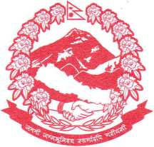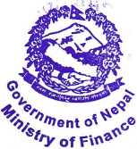

GAFSP Coordination Unit The World Bank 1818 H Street

Washington DC, 20433 United State of America

**Subject: Submission of Country Proposal: Nepal**

Dear Sir or Madam,

We hereby submit a proposal from the Government of Nepal to the Global Agriculture and Food Security Program (GAFSP) for funding the Vegetables in Hilly Areas Project, with the Asian Development Bank (ADB) and the World Food Programme (WFP) as supervising entities.

Around 66% of Nepal’s rural population continues to rely on agriculture for their livelihoods, but household income is increasingly covered by remittances. The COVID-19 pandemic has seen a large influx of the population returning to Nepal, especially during severe outbreaks in neighboring India, which is a major migrant labor destination. The large outmigration has resulted in an estimated 25-30% of land in the mid-hills being left fallow. With declining migrant labor opportunities, the COVID-19 pandemic has exacerbated rural poverty and livelihoods. In this backdrop, the Asian Development Bank is supporting the Government of Nepal develop the Nuts and Fruits in Hilly Areas Project, which seeks to promote profitable fruit and nut orchards in Nepal’s mid-hills.

We propose for your consideration, the Vegetables in Hilly Areas Project to be closely aligned to the ADB-financed project as a complementary intervention targeting the smallholder and poor households in the project areas. The GAFSP project will assist poorer farmers who are outside the scope of the ADB-financed project to develop less capital-intensive horticulture activities, notably out of season vegetables, which would also contribute to household nutrition. GAFSP project beneficiaries would also benefit from the ADB-financed project interventions on small- scale irrigation, horticulture husbandry, digital information sharing, cooperative based technical support and product value addition, thereby contributing to medium- to long-term COVID-19 response efforts for a more sustainable, inclusive, and resilient recovery of their agriculture and food systems. Furthermore, the project will be implemented following the spirit of Nepal’s new constitutional provision of federalization, with the five provincial governments leading implementation. The proposal is fully aligned with the Agriculture Development Strategy (2015- 2035) and supports the government’s vision for transitioning Nepal’s agriculture sector towards commercialization.

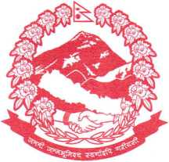Government of Nepal

MINISTRY FINANCE

Q

The Government and the Development Partner’s Food Security Group discussed the GAFSP proposal on 22 June 2021 through an online meeting, and a subsequent meeting was held on 5 July 2021 among selected development partners eligible as supervising entities. The Government’s proposal to select ADB and WFP as supervising entities and the scope of the GAFSP proposal and alignment with the Nuts and Fruits in Hilly Areas project was agreed and endorsed by the Development Partner’s Food Security Group. A team of officials at the Ministry of Agriculture and Livestock Development led the proposal development in close coordination with the provincial ministries of agriculture, and technical assistance from ADB and WFP.

>ofFina^®

**SINGHADURBAR  
KATHMANDU, NEPAL**

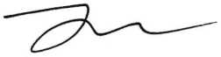We hope for a favorable consideration by the GAFSP Steering Committee on the Government of Nepal’s proposal.

Janardan Sharma Minister for Finance Government of Nepal